ASSIGNMET-2
AI-Powered Customer Support Automation System

Github Repo Link :

File Structure
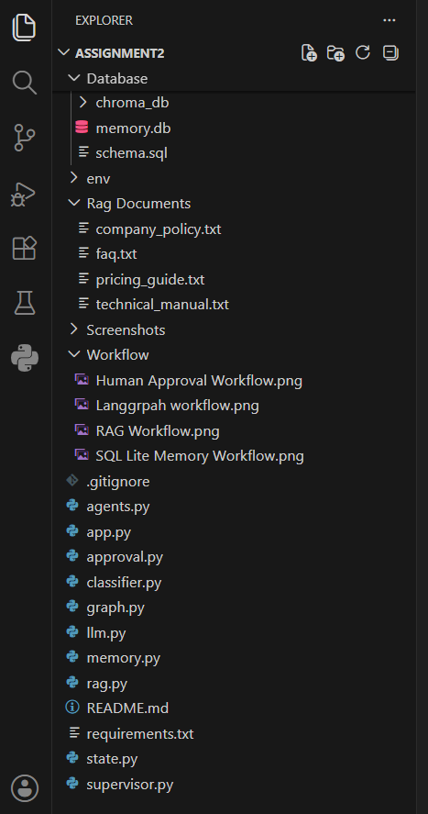

Work Flows (Task 1)
LangGraph WorkFlow
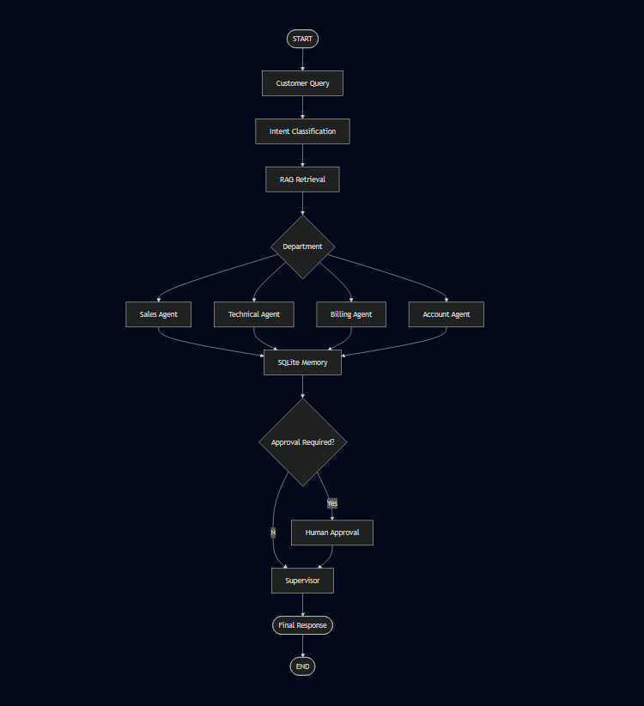
RAG WorkFlow
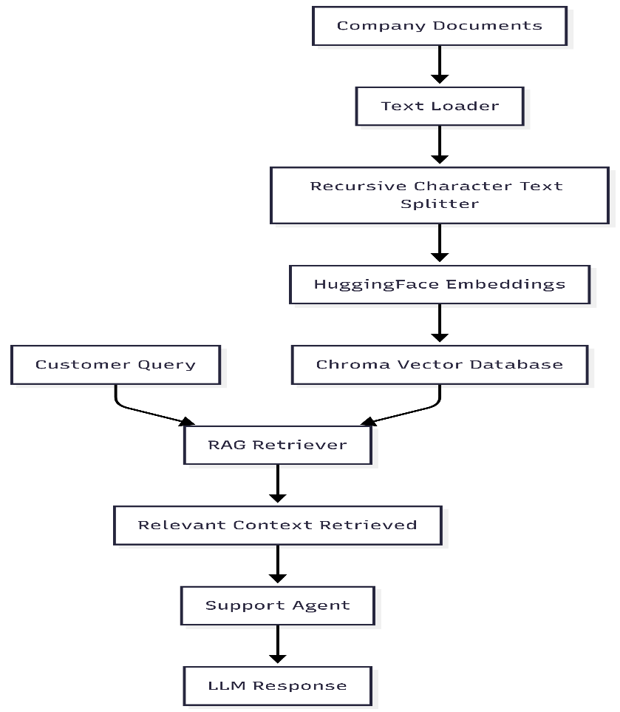
SQL Lite WorkFlow
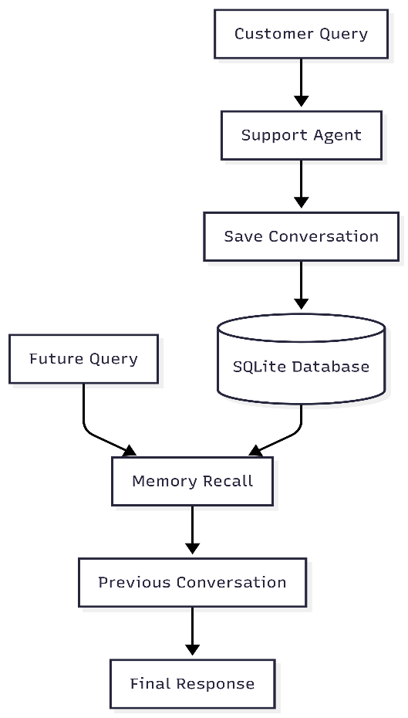
Human Approval WorkFlow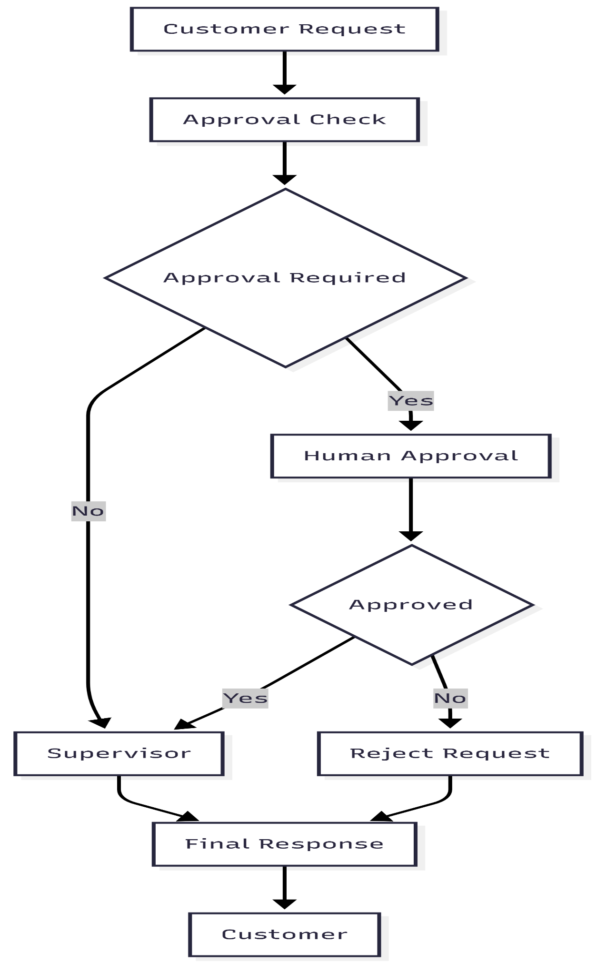
OUTPUT SCREENSHOTS:
Teminal
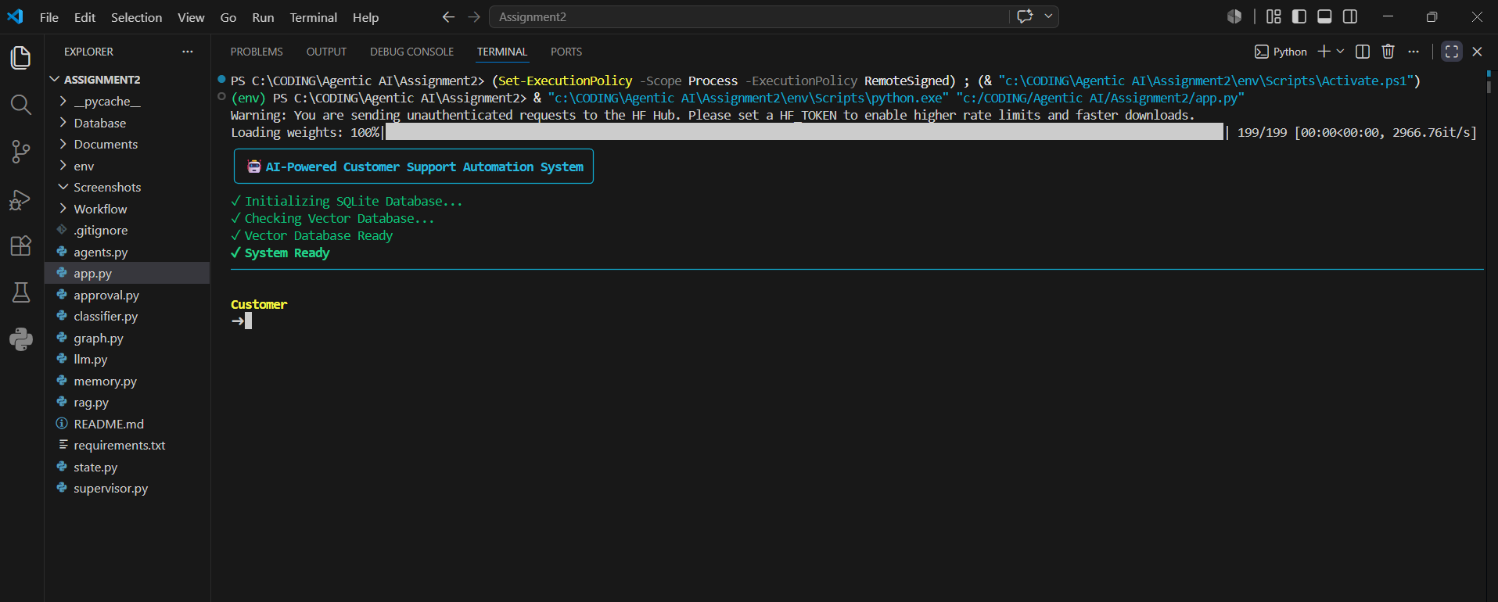
Query 1
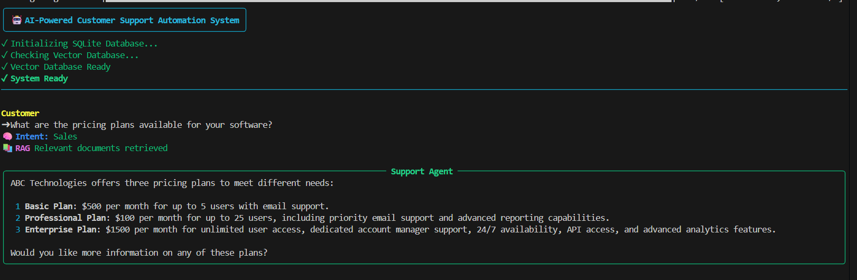
Query 2
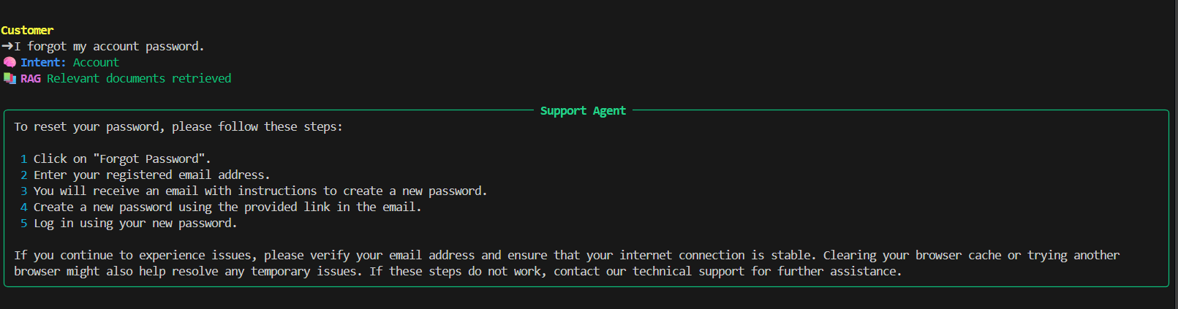

Query 3
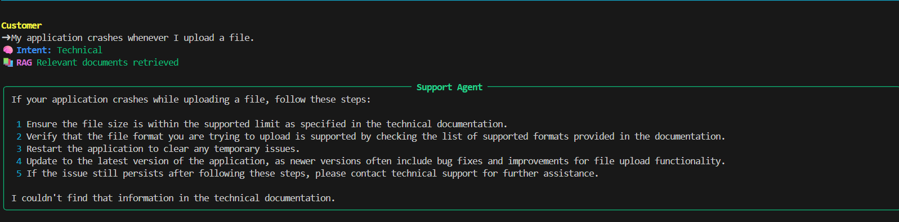
Query 4
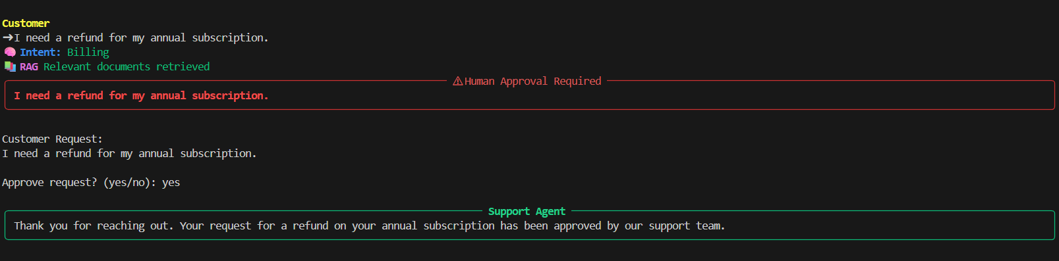
Query 5
